BeechCraft Bonanza G36 Turbo Mod
for Microsoft FS2020 - Version 2.0
by Robert Young – October 15th - 2020

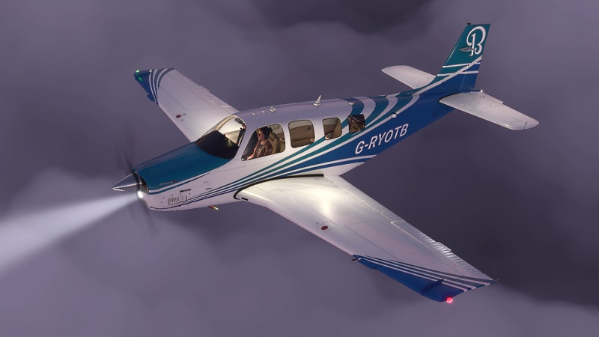New -Turbo Blue-Aqua Livery

Version 2 Changes, Fixes and Additions

New in V2
** Custom prop animations on start-up and shutdown (* please see note below)
** Less abrupt starting and shutdown
** Three additional liveries – now totalling nine
** More subtle nav/strobe lighting
** Comprehensive suite of ambient lighting and enhanced reflections
** More elevator needed on landing flare and better slow speed handling
** Adjusted prop spool-up speed and more realistic engine reaction to inputs
** Flight model improvements
** Improvements to suspension and ground handling
** Side slipping improved
** Maximum take-off weight increased to 4000 lbs as standard with Turbo kits (*see note 2)
** Guide now includes section on EGT/temperature management
Note* Though the prop animations have been improved, the default prop template rather abruptly stops the propeller as it reaches very slow speed. This appears to be hard-coded and at this time I cannot find a way to improve it. However the prop start-up and shutdown animations are a significant improvement in V2.
Note 2* The increased all up weight to 4000 lbs is FAA approved and is a consequence of both the added weight of the turbo installtion and the fact that the turbo increases performance. However the climb rates in the tables further down this document are for a payload that is the standard Max of 3650 lbs. If you add extra load to the max 4000 lbs then expect approximately 100 feet per minute lower climb rate.
Fixed issues reported and discovered
1. Depending on fuel load, Bonanza would be unstable on some surfaces: fixed.
2. Mixture control settings would cause occasional instability in flight model: fixed
3. High altitude airports caused ground instabiity : fixed
4. Flap detente lights not working: fixed
5. Beacon and strobe lighting would “leak” into cockpit creating a distraction : fixed
6. C of G moved in order to provide better ground stability with any payload

Introduction
This mod has now taken approaching 250 hours work and represents a comprehensive remake of the default Beechcraft Bonanza in MSFS 2020. It is not a fictional makeover but as near as possible to the actual turbo-normalised Bonanza modification of the type offered by Tornado Alley and other turbo engine mod suppliers.
This package will radically improve the climb and cruise performance of the default Bonanza, consistent with real-world improvements to the engine as offered by turbo-engine modifications enjoyed by owners of the real Bonanza G36.
In the package is a comprehensive redesign of every flight model and engine detail within the current limitations of MSFS 2020. There are many features included and in version 2 the following enhanced features are:

* Nine custom liveries.
* Brighter navigation & strobe lights, nav light splashes and new wing lights.
* Brighter and much longer range landing & taxi lights.
* Better suspension and landing gear handling on the ground.
* Elimination of twitchy rudder on the ground and take-off run.
* Full steering angle at low speeds yet controllable at high speeds.
* Rock steady autopilot at normal simulator speed at all altitudes.
* Elimination of random twitchy behaviour in non turbulent conditions.
* Temp gauges more realistic.
* Engine changed to 6 cylinders with correct displacement
* Elimination of “baked in” artificial oscillations that are not weather related
* Elimination of artificial movement not related to landscape or air mass
* Harmonised and balanced controls with no pitch bobbing up and down
* Accurate aileron authority and roll rates at all airspeeds
* Proper spins rather than the default spiral dive
* Full side slip capability with up to 30 degrees slip angle
* Correct climb rates and cruise speeds for the turbo version
* A complete overhaul of flight dynamics
* Compatible with Working-Title’s G1000 mod or the default G1000

How to install this mod
Using this mod will convert the default FS2020 Bonanza G36 into a turbo-aspirated aircraft with much higher climb rates and cruise speeds than the default aircraft. Included are also nine attractive custom liveries based on the default colour scheme.
If after trying it you prefer the original FS2020 version, then simply remove this mod by following the instructions below.
To install, extract the “Bonanza-Turbo-V2” folder of the zip file into your FS2020\ packages\community folder. The paths of the community folder differ according to where you purchased the simulator (Microsoft direct or Steam). For guidance on the location of your community folder please go here:
https://www.flightsim.com/vbfs/content.php?21235-Finding-The-MSFS-2020-Community-Folder
To fly with either the default livery or custom liveries, start FS2020, navigate to the "World" sphere, choose your airport and click top left to choose your Bonanza G36 and then choose a livery of the seven available (including the default).
Additionally you can go to the Hanger in FS2020 and view the custom liveries in this package.
Note: This mod is compatible with the excellent G1000 glass gauge mod by Working Title. As of the current date the mod comes ready-loaded with a custom G1000 profile for the Bonanza, which provides EGT readouts and some great enhancements to the standard FS2020 G1000 gauge. Version 3 of the mod can be downloaded here: https://github.com/Working-Title-MSFS-Mods/fspackages
Note : Please remove Version 1 out of your community folder before installing this update version 2 !
V2 is not an addition to V1 but the complete mod.

Uninstalling
To uninstall, quit FS2020, then delete this package from your community folder. When you next start FS2020 the Bonanza will revert to the default engine, flight model and features.
NOTE: The mod must be used with the "Modern" flight model option. It will not work with the "Legacy" flight model. To check you have the correct option, with FS2020 running press escape then in the drop down menu click on "flight model" and if necessary change the option to "modern" then "apply and save".
To achieve the advertised performance you must also use manual mixture controls (see below)
CONTENTS OF THIS MOD
Files in this package are placed entirely in the FS2020 community folder and do not affect any default sim settings or files. They do not replace or substitute any core features of the sim and are perfectly safe to use if you install this package correctly.
The folder structure is as follows: FS2020\Packages\Community\Bonanza-Turbo
Documents - including the one you are reading now.
Effects - containing the custom lighting.
Simobjects - containing the custom flight model, custom engine, textures, camera & light settings.
Root folder - Manifest, Layout and descriptions in multiple languages.

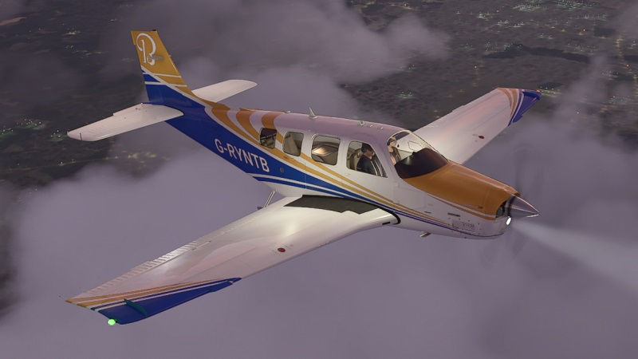
Recommended Settings
In order to get the best out of this mod, please review the settings below:
1. Mixture should be set to “Manual” in the assistance menu of FS2020. This will enable you to achieve the intended climb and cruise performance. If you set mixture to “auto” there is no guarantee that the Bonanza will perform as intended.
2. The custom landing light beam works best with “light shafts” set between medium and ultra in the graphics menu. The higher the setting the more the volumetric beam will show. The “aerosol” setting in the weather/clouds menu also profoundly influences how intense the light beams are. With high aerosol settings the beam will be too hazy. I recommend switching aerosol levels to zero or a modest amount.
3. The ambient wing lights are tied to the floodlight bus. If you switch off the floodlights via the cockpit switch, the wing lights will also switch off.
4. Control sensitivities are a matter of personal taste. However if you set extreme low or high sensitivity in any control axis, you will likely get spikes of unintended control authority. The only exception is in rudder control where low sensitivity (but not too much) will alleviate the sim’s tendency to exaggerate ground steering at low to medium speeds.
5. The autopilot is configured to be completely stable in this mod. At normal sim speeds it should provide total stability at any altitude and any speed. You can also safely run the sim at 2x or 3x normal speed and the autopilot will still be stable. At sim speeds of 4x and above there is no guarantee of a/p stability.
6. The mixture control is designed by default to be the engine manufacturer’s 20 degrees rich of peak at sea level when the lever is at 100%. To attain top sea level speed you may need to slightly lean the mixture to around 96-97%.
7. In options/general click on “flight model” and make sure you have enabled the “modern” flight model. This mod will only work properly with this option.
8. The glareshield lights have been brightened so you can see the panel more easily in harsh sunlight. This will require turning down these lights at dawn, dusk and night-time via the dimmer knob to the right of the panel.
About the Bonanza G36 and what this mod does
The Turbo-Normalised Bonanza converts an already impressive and luxurious aircraft into possibly the most accomplished single piston-engined aircraft with six seats available. It vastly increases the effective power, speed, climb and cruise capability while at the same time offers similar fuel economy to the normally aspirated G36. It does this by taking exhaust gases and diverting them via a high speed impeller into a system which forces much more air into the engine intakes. "Normalised" means the turbo engine achieves full power (manifold pressure) of over 29 inches all the way up to 18000 feet and gives the Bonanza an effective ceiling of 25,000 feet.
It also radically transforms the speed capability of the Bonanza, which now has class leading climb and cruise speeds while at the same time keeping fuel economy equal to or even lower than the normally aspirated version for comparable distance.

Below is a summary of performance figures for the turbo version:
Climb – 1,400 feet per minute at sea level and 1,300 feet per minute at max take-off weight from 4,000 feet up to 8,000 feet . 1,200 fpm up to 11,000 feet. 900 to 1000 feet per minute up to 17,500 feet.
Cruise Climb at 130-140 knots TAS all the way up to 22,000 feet abd beyond!
Approximate Maximum Cruise Speeds with throttle wide open: -
183 knots (210 mph) at sea level - 2700 rpm (with 97% mixture as 100% is rich of peak even at sea level)
197 knots TAS (227 mph) at 11,000 feet - 2500 rpm
212 knots TAS (243 mph) at 17,500 feet - 2500 rpm
207 knots TAS (238 mph) at 22,000 feet - 2500 rpm
Best cruise speed = 222 knots TAS (255 mph) at 17,500 feet – 2600 rpm
Note: the above speeds (except at sea level) can be higher still with full 2700 rpm but for engine reliability /fuel economy I assume setting typical cruise rpm of approximately 2500 rpm.
Note 2 : In order to achieve the performance highlighted above, it is necessary to use manual mixture in your FS2020 "Assistance" settings. If you fly the Bonanza with auto-mixture it will not perform as intended.
I recommend watching https://www.youtube.com/user/LimitlessHz which is Matt Guthmiller's YouTube channel. Matt went round the world in his Bonanza A36, and his many videos of take-offs and landings in his Bonanza demonstrates just how stable and easy to fly this aircraft is.
Below is another useful link to turbo-normalised Bonanza owners discussing their pride and joys. The comments give a very positive insight as to how brilliantly the real-world Bonanza performs with the addition of a turbo modification: https://taturbo.com/comments.html

CONTROLS SETUP AND SENSITIVITIES
This mod is designed so that a typical consumer controller like a joystick or yoke and rudder pedals should not need much adjustment in order to keep good control of the aircraft. This is a controversial subject, but my feeling is that having to set controllers (apart from playstation-types) with very low sensitivities means while the first part of controller movement seems easy, as you near the end of movement there will be an exponential spike of control surface authority.
This is often used as a solution to flight model settings that are fundamentally too sensitive, especially in pitch and yaw. The fight model in this package is designed so that there is no need to compensate through extreme sensitivity settings in controllers.
The only exception in this mod's case is that the rudder controls might need some low sensitivity as ground handling in FS2020 can be quite difficult even with careful calibration of steering values.
That said, it is entirely up to the user what sensitivities to use and I am just giving an explanation, not a recipe or advice!
Below are descriptions of this mod's flight and engine modelling compared with the default Bonanza, from start up, through take-off, climb, and cruise.

STARTING THE ENGINE
After loading the Bonanza you may need to start the engine as sometimes aircraft load with the engine already running and other times the engine is not running. Until it warms up you will need to advance the throttle a very small amount if you need to start the engine. Once warmed up the engine will run idle with the throttle lever fully back.

GROUND HANDLING
Asobo introduced a very welcome increased ground friction model in FS2020. One problem however is that lateral friction is overdone, resulting in too much nosewheel grip during taxi and take-off, making it difficult to keep straight. This mod tones down the excessive squirming of rudder and nosewheel steering, allowing a good, tight turning circle at very low speeds but much more controllable steering on the take-off run. This has been achieved through very careful tweaks of the flight model.

YOKE CONTROL IN ROLL AND PITCH
In still, undisturbed air, nearly all aircraft display remarkably good pitch stability, and the real Bonanza G36 is no exception, having one of the most beautifully harmonised, easy-to-fly set of controls in aviation. It should not be unpredictable or twitchy at all. Asobo has attempted to get away from what they assume to be "flying on rails" by imposing somewhat artificial effects outside of the actual flight model in order to give an impression of instability or twitchy behaviour. They have also lowered the effective inertia of most GA aircraft to give the impression of dynamic movement. But all this does is make aircraft like the Bonanza difficult to control, especially in pitch, when it should not be.
This mod as far as possible minimises these artificial effects, increases the pitch stability and cuts down the roll rate to reasonably accurate levels. In fact this mod still allows the sim pilot to fly the Bonanza with great gusto and (though not officially cleared to do so) it can even do modest aerobatics including stall turns, hammerheads, spins, loops and aileron/barrel rolls.
At the same time it is much more controllable in normal operations, and especially on take off rotation, approach, flare and landing. There is no more bucking up and down in pitch. As the airspeed falls away on landing, the controls become correctly floppy and less responsive, roll rates substantially reduce and flying should now be a pleasure, not a permanent fight to keep basic control.

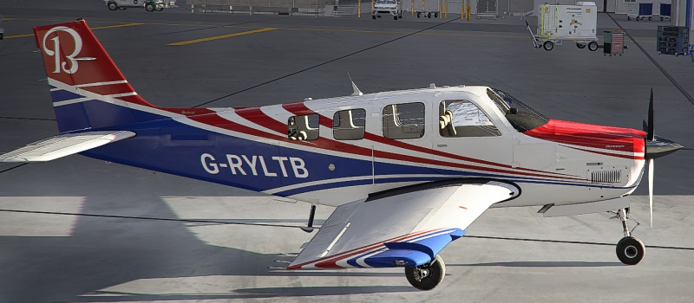Turbo Red-Blue Livery

TAKE OFF - CLIMB AND CRUISE
IMPORTANT!!! Before flying this version (or indeed most default aircraft in FS2020) I strongly advise you to move your controllers to their fullest extent in all directions once the aircraft is loaded into the sim, and especially the ailerons control. There is a bug in FS2020 that sometimes links the pitch control to trim, especially if you reload the aircraft using the developer-mode "resync" and not moving the ailerons fully in both directions
If you are getting odd behaviour or the controls are not performing as expected, or the Bonanza is unstable in trim or other ways, it will be because you need to fully deflect all of your stick/yoke/rudder controls before flying, immediately after you load the Bonanza. This will properly initialise the controller axis elements and ensure that your calibration is recognised by the sim.
Before take-off, check you have selected one stage of flaps and select neutral trim.
This mod's flight model is designed so when maneouvring at low speeds you will need more elevator input than with the default aircraft, which is too sensitive in pitch at low speeds.
I recommend flying for at least a while without autopilot to get a feel of the controls, which are very different from the default Bonanza in FS2020.
Though the standard climb angles and speeds are appropriate for the normally-aspirated Bonanza, the Turbo engine performs just as well or better still when climb speeds are substantially greater than standard. Typically you can climb very efficiently at 130-140 knots. You should see 1,300 feet per minute at full power even fully loaded, and up to initially 1400+ fpm with lighter fuel and passenger loads. There is no need to reduce prop RPM in the climb with a turbo-normalised engine, except for fuel economy. The faster prop rpm will help cool the increased heat created by the turbo installation. For full performance in the climb select 2700 rpm and full throttle.
The turbo-normalised engine affords the full 29+ inches of manifold pressure all the way up to 18,000 feet! Thereafter power drops away slowly.

MIXTURE CONTROL
It has not been possible in this version to calibrate the mixture control with absolute accuracy. That is because FS2020 (and its predecessor, FSX) has a hard coded mixture routine that is not very realistic. A turbo-aspirated engine should not require leaning until reaching medium altitudes.
Nevertheless, though the mixture is not perfect, I have modded the mixture control as far as possible to be better than the default.
(For a detailed guide to mixture, power and rpm settings please view the tables and further info towards the end of this document).
The standard is to select 20 degrees rich of lean peak. To achieve this without a proper EGT (Exhaust Gas Temperature) gauge is still possible by reference to the fuel flow, the rpm gauge and the sound of the engine.
Let's take an example. You are climbing from, say, 4,000 feet to 15,000. As you climb reduce the mixture percentage so that the fuel flow pointer begins to drop. If the fuel flow gets too low the engine will eventually sound different and power will drop. When you reach that point, enrich the mixture so the engine tone and power increases again, then add a tiny bit more than that. That will be close to 20 degrees rich of lean peak. If you are using full power and 2700 rpm, the lean peak point will cause the engine rpm to temporarily exceed 2700 rpm as the prop governor lags slightly behind the prop speed, and the rpm gauge readout will turn red. This is a useful indicator of the lean peak point
The sound of the engine will be more urgent when the mixture percentage is approximately correct. The audible engine tone will drop both with too rich AND too lean mixture settings.
When cruising at, say, 17,500 feet at 2500 rpm and full throttle (the altitude for optimum performance), the mixture control will need to be somewhere around 22-23%. You should see approximately 15 or so gallons per hour on the fuel flow gauge. Less than that value means you are too lean. Above 16.5 gallons per hour means you are running too rich.

Using propeller rpm as a fuel flow adjuster
In turbo-normalised piston aircraft you can use propeller rpm effectively as a fuel flow adjuster. At higher altitudes, reducing the prop rpm from, say, 2600 rpm to 2400 rpm will also lower the fuel flow substantially. If you wish to take a very long flight, or just practise economy flying, lowering the rpm will save fuel especially at high altitudes, at the cost of some climb and speed performance.
Some suppliers and experienced users of turbo-normalised Bonanza kits recommend full power (or wide open throttle) for the entire climb, saying it is unnecessary to reduce power as it gives no particular advantage in engine wear or heat, and some claim it might actually increase engine wear if you lower either the power or the rpm.
Either way, this Bonanza mod will deliver stunning performance compared with the normally aspirated engine, and that is a reflection of the capabilities of the real turbo aircraft.
If you set full power for the whole climb with a low fuel or passenger payload you can expect even higher climb rates and cruise speeds than those given in the summary section of this document.

COWL FLAPS, CHT and OIL TEMPS
Cylinder Head Temperature has been adjusted so that running the engine on the ground at high rpm will gradually raise the CHT towards the red mark. This requires you to use at least 25% open cowl flaps to taxi and run up if you use a lot of power or delay take off for some reason. The cowl flaps will ensure the engine cylinder heads and oil do not overheat whether on the ground or climbing under high power at slow airspeeds.
Once you are above 130 knots at medium to high altitude you can close the cowl flaps safely.
(Note: please see section below on temperature management for more info on this subject)
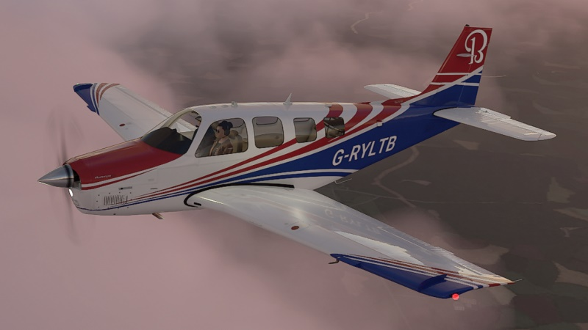
CRUISE ALTITUDES
The turbo Bonanza will easily climb with full power right up to 18,000 feet. If you are cruising even higher then the best altitude for fuel economy and speed is around 22,000 feet. At this altitude you can easily achieve 211 knots (True Airspeed) or 243 mph, with a fuel flow as low as 13.5 gallons per hour.
You can get as high as 25,000 feet (assuming you have oxygen!) but the climb rate falls away to around 400 fpm after 22,000 feet. At 25,000 feet the mixture will be less than 18%. I am not sure this is accurate but in any case the hard-coded mixture modelling in the sim dictates that you need quite low fuel-air mixture ratios once you leave low altitudes.

STALLS, WING-DROPS and SPINS
This mod has a flight model that will stall benignly if you immediately release the elevator to neutral, or will stall more deeply if you hold the elevator back against the stall. Depending on weather conditions, your angle of attack, attitude and trim settings, a stall can turn into a wing drop. If you stall with some up trim and you hold the elevator hard back so the airspeed falls below the top of the red airspeed tape, you will likely get a wing drop and either an incipient spin, or a full spin if you also fully depress the rudder in the direction of the wing drop.
The default aircraft do not spin properly. They tend to just spiral dive using high values of induced drag to contain the airspeed acceleration.
A deliberate full spin is very distinct to the trained eye. It requires first a wing to drop with full rudder in that direction while initially holding the elevator fully back. An authentic spin has a very particular characteristic. The nose of the aircraft will "tuck under" the dropped wing and with the elevator released but full rudder in the direction of the spin, the aircraft will stabilise in speed just above the stall (around 68-78 knots in the Bonanza) while spinning. A full spin is not a spiral dive but broadly equal amounts of yaw and roll, both of which create their own induced drag that holds the airspeed a little above the stall.
If you wish to practice full spins the procedure is as follows:
1) Climb to at least 4,000 feet.
2) Pull back the yoke so speed drops with idle throttle.
3) Add a little up trim (not too much) near the stall and continue pulling the yoke back.
4) At the stall keep the yoke FULLY back.
5) As the stall commences you will likely get a distinct wing drop.
6) When the nose "tucks" right under the dropped wing, smoothly and gradually apply full rudder in direction of turn after centralising the yoke. Do not “stamp” on the rudder!
7) Keep full rudder throughout the spin.
8) Once established, the spin will "stabilise" at a constant speed and spin rate.

If you release full rudder while spinning, the aircraft will accelerate and may continue spinning or may self-recover. This mod attempts to get as close as possible within FS2020 limitations to an authentic spin.
To recover from a fully developed spin, slightly push forward on the elevator and if necessary apply opposite rudder.
Spins and load factors
You can spin the modded Bonanza at any height with any payload and it will spin reliably, using the stall/full rudder method. Additionally, if you are close to maximum weight with fuel and payload, this shifts the C of G back and in these circumstances the Bonanza will auto rotate after a stall with full elevator and little or no rudder.
SIDE-SLIPS
Most default GA aircraft in FS2020 do not side-slip very well, and can only achieve a very small slip angle. This mod enables the Bonanza to side-slip fully and this is most useful as a method by which you can lose altitude quickly if you are too high on final approach. With half to full rudder you can achieve from 10 to 25+ degrees slip. To slip effectively, input the desired amount of rudder (the more rudder the greater the slip angle) and apply some opposite aileron to balance the side-slip and achieve a stable direction in line with the runway centre line. (Note: in UK English “side-slip” also means “forward-slip”)
AEROBATICS
Although only special editions of the Bonanza have been cleared for full aerobatics, you can fly some simple aerobatic maneouvres using this mod. It will easily achieve a loop (with entry speeds close to VNE) when lightly loaded with fuel and passengers. It will also do stall turns, chandelles, snap rolls, aileron rolls, barrel rolls and hammerheads.
To achieve a hammerhead, accelerate to around 170+ knots. Pull up into a 90 degree climb and when the airspeed drops to around 90 knots, kick in rudder in the desired direction of turn with around a quarter throttle. This amount of power helps the turn. It is important to keep the climb dead straight and keep the wings perfectly level until the turn is initiated near, but not at, the stall.

THE LIVERIES
The included nine custom liveries (Version 2) are simple colour changes based on the excellent default decals and paint scheme.
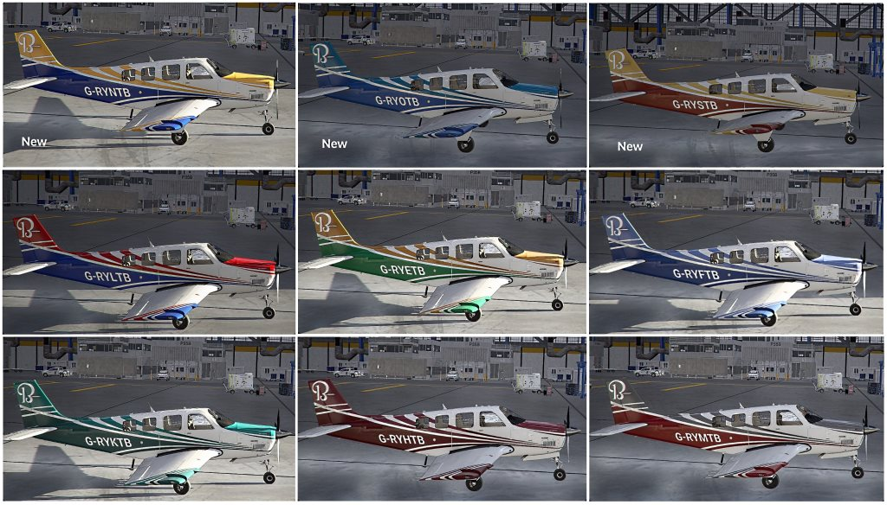
MORE ABOUT POWER – RPM - AND FUEL FLOW
In turbo-normalised aircraft there is no advantage in climbing or cruise-climbing at vx and vy (best climb rate and best angle of climb) except possibly for safety reasons - but that is also debatable – or using low power settings. A full power climb at max rpm of 2700 and 130-140 knots will cool the engine more efficiently and will climb just as well as a slower climb speed. Climbing at high speed makes progress to your destination, will not harm the engine and is only marginally less economical in the long run.
There is also little point in not using the turbo-powered full manifold pressure at almost all stages of flight, unless you want to under-use it by going back to normally aspirated settings, in which case there would be no point in having the turbo engine!
The key thing to grasp is that with full power right up to 18,000 feet, there are better ways of saving fuel consumption than reducing manifold pressure.
Once you are at cruise altitude, keep the throttle wide open and lower fuel consumption by leaning the mixture so the fuel flow decreases, but not so much that the engine runs “rough” or starts sounding less urgent. The official 20% rich of lean peak is a good start.
As you reduce rpm to 2500 you’ll notice that the fuel flow also decreases. This is much more efficient than pulling the throttle back. Leave the throttle wide open and reduce fuel consumption through mixture and rpm.
Below are tables showing the key performance values to be expected after a Maximum Take Off Weight climb and cruise to the specified altitudes.
With half fuel and just two pilots you can expect climb rates to be substantially higher but cruise speeds remain broadly similar.

POWER | CLIMB TO | CRUISE AT | CLIMB RATE | RPM | SPEED | COMMENTS
29.6 inches | 4,000 ft | - | 1400 fpm | 2700 | 120-125 IAS | Best climb rate
29.6 inches | 4000ft - 8,000 ft | - | 1300 fpm | 2700 | 124-130 IAS
29.6 inches | - | 8,000 ft | - | 2500 | 191 kts TAS
29.6 inches | 8000ft - 11,000 ft | - | 1250 fpm | 2700 | 126-133 IAS
29.6 inches | - | 11,000 ft | - | 2500 | 198 kts TAS | Highest w/o O2
29.6 inches | 11000ft - 17,500 ft | - | 1200 fpm | 2700 | 135-140 IAS | Oxygen needed
29.6 inches | - | **17,500 ft | - | 2500 | 212 kts TAS | *Best cruise *
*WOT | 17500ft - 22,000 ft | - | 1000-900 fpm | 2700 | 130-135 IAS
*WOT | - | 22,000 ft | - | 2500 | 206 kts TAS
*WOT | 22000ft - 25000 ft | - | 500-400 fpm | - | 130-135 IAS
*WOT | - | 25,000 ft | - | 2500 | 197 kts TAS
* WOT =wide open throttle . * *After 18,000 ft manifold pressure gradually drops .
NB: Climb rates are approximate and may vary with weather conditions and o/s temp and pressure.

Below are approximate fuel consumption values vs Speed/RPM at various stages of flight
CRUISE AT | POWER | RPM - *gals/hr - speed | RPM - *gals/hr - speed
8,000 ft | 29.6 inches | 2500 - 17.9 - 191 Tas | 2400 - 17.3 - 186 Tas
11,000 ft | 29.6 inches | 2500 - 17.5 - 196 Tas | 2400 - 16.7 - 194 Tas
17,500 ft | 29.6 inches | 2500 - 16.8 - 212 Tas | 2400 - 15.1 - 206 Tas
22,000 ft | **WOT | 2500 - 14.7 - 203 Tas | 2400 - 12.6 - 198 Tas
25,000 ft | **WOT | 2500 - 12.6 - 196 Tas | 2400 - 11.9 - 193 Tas
* slightly rich of peak – varies with o/s temp and pressure. **wide open throttle – MAP drops from 18,000 ft
Note 1: Add 8+ knots of speed for above altitudes with 2600 rpm compared to 2500 rpm
Note 2: Add 12+ knots of speed for above altitudes with 2700 rpm compared to 2500 rpm
Note 3: Absolute top cruise speed = 222 knots TAS @ 2650 rpm 19.6 gals/hr 17,500 feet
Note 4: Substantially lean of peak will deliver lower speeds but far greater economy

MANAGING ENGINE TEMPERATURE
There are many different opinions about mixture enriching and leaning, and their relationship with CHT (Cylinder Head Temperature) and EGT (Exhaust Gas Temperature) among Bonanza A36 and B36 owners. There is no consensus. Some aim for standard lean of peak, others rich of peak (as recommended by Beechcraft but not necessarily recommended by suppliers of Turbo modifications.
The standard/default G1000 glass gauge in the FS2020 Bonanza only shows CHT, and this mod has calibrated the CHT reading so that you will probably need Cowl Flaps either on hot days while climbing and certainly when on the ground – where the temperature builds up due to lack of natural cooling when running up the engine or taxiing.
Once you exceed around 130 knots and climb to medium altitudes (4000 feet and above) the need for cowl flaps lessens as the progressively colder airstream provides engine cooling.
CHT will rise steadily after start up, particularly if you run the engine much more than idle. Cowl flaps are therefore essential on the ground and for the initial take-off and climb.
Thereafter the CHT drops away and the concern is now to monitor EGT. Unfortunately there is no EGT reference on the default G1000 but the excellent G1000 mod by Working Title (see link above) does show an approximation of EGT.
If you are using the G1000 mod as well as this mod you will have access to EGT monitoring while you are adjusting the mixture control in cruise conditions. The best way to find out more about this is to watch an excellent YouTube video published by Martin Pauly who discusses in great detail his approach to mixture leaning and temperature control. His explanations are far more detailed and illuminating than this guide could achieve since you will be watching an excellent video demonstrating precise and detailed live EGT temperature management.
Here is the link to Martin Pauly’s demo:
https://www.youtube.com/watch?v=h3bATVXMHQg&t=281s
While he does not own a turbo version of the Bonanza, his guide is very relevant to this mod.
OTHER USEFUL DOCUMENTS
For copyright reasons I cannot directly publish some very useful documents . I am grateful to Ray Marshall, the well-known Avsim reviewer of addons, for his links and advice on finding good resources for information about this mod.
Below are some links that Ray has sourced which enable you to gain good insight into general operation of the Turbo Bonanza:
http://pohperformance.com/Bonanza/
https://vansairforce.com/community/showthread.php?t=75132
http://www.malusflyers.com/Malus_Flyers/Malus_Flyers_files/AFMS-550%20Rev%20H.pdf
The last link above is the official supplement for owners of the turbo modification.

LIGHTING MODS
Included in this package are several lighting features which significantly improve on the default lights. They are further enhanced in Version 2, particularly regarding the promotion of reflections, lighting balance and atmosphere.
Landing lights in FS2020 are far too short in length to be of practical use. This mod lengthens the landing light beam by over five times compared to the default and the beam starts at a better distance from the nose of the aircraft. In addition the taxi lights have a slightly different hue so they are distinguishable from the landing light. The taxi light beam has also been moved forward, has lengthened and widened so you get a much better view ahead.
Nav and strobe lights are slightly bigger, brighter, and they now show a subtle “splash” reflection at night on lighter shaded runways.
There is now wing and stabiliser ambient lighting including ambience from red and green nav lights visible from the cockpit.

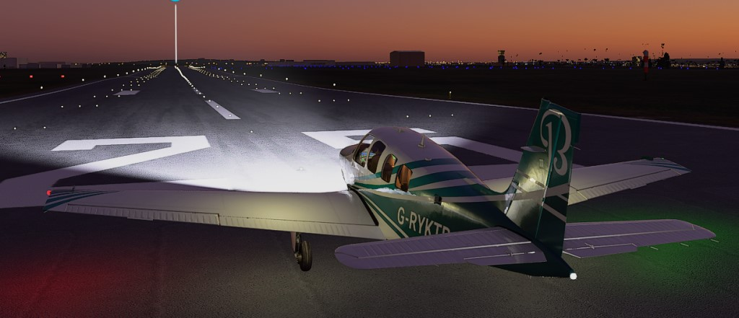The Light Beam is accurately placed

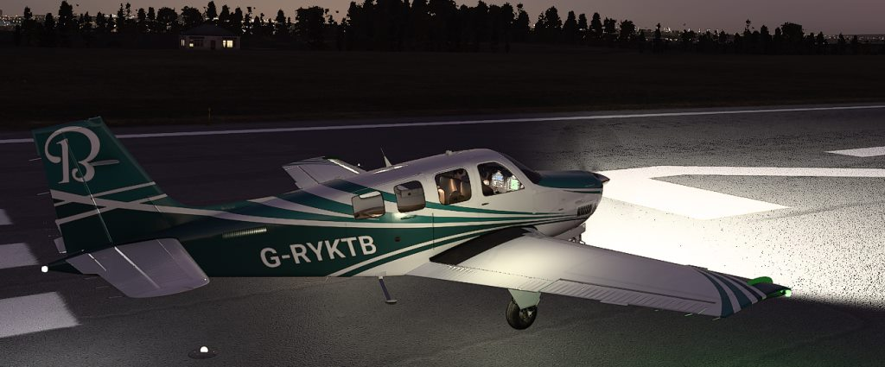

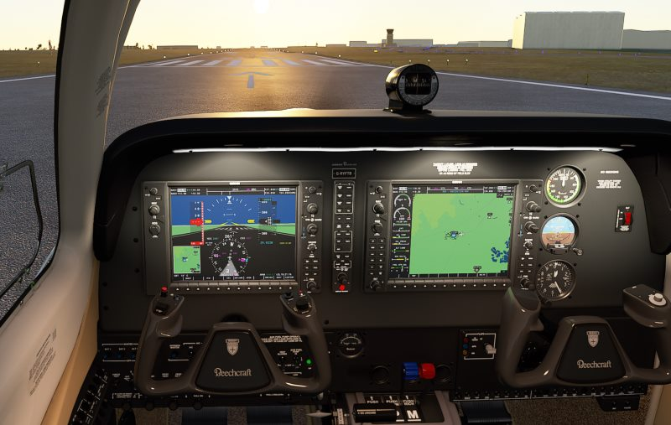
Panel lighting is brighter against harsh sunlight

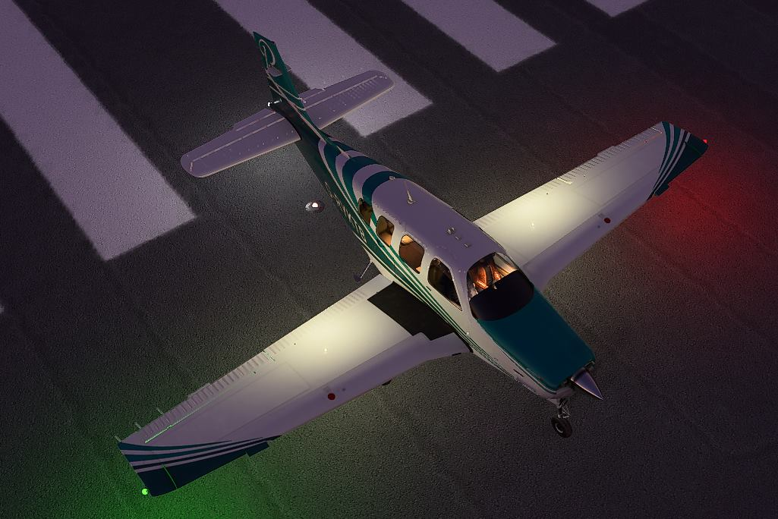
Ambient wing lighting & nav light splashes

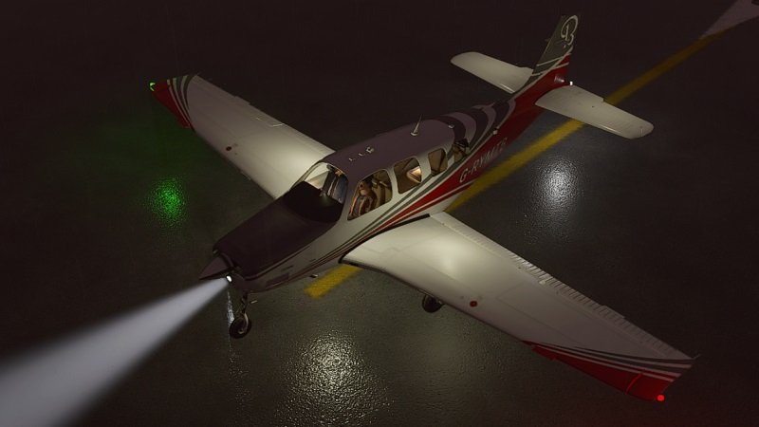

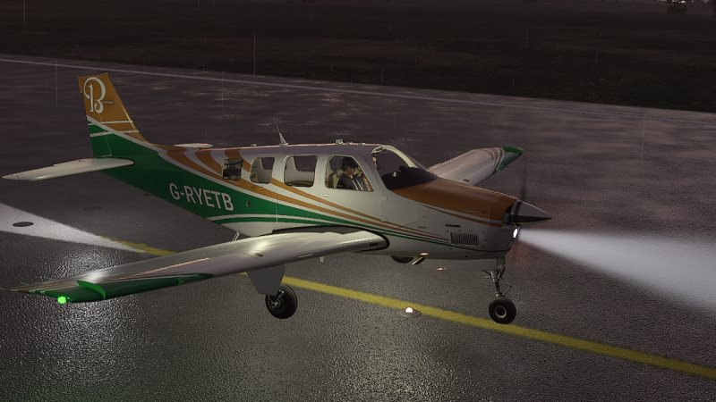
ACKNOWLEDGEMENTS
I wish to thank all those who have encouraged me to develop and improve the Bonanza Turbo Mod. There are too many to mention all of them but I would like to express my thanks to a few people who have been exceptionally supportive and generous:
Carl Avari-Cooper (cavaricooper at Avsim) whose outstanding kindness and encouragement has been instrumental in helping me keep up the energy required to improve this mod.
Ray Marshall (raymar at Avsim) who has provided many links and sourced documents that have helped me improve this mod. Ray has also been a long-time supporter of my work over many years.
DJJose (Avsim handle) who has tirelessly galvanised support and donations for the work put into this mod.
cwburnett and all the team at Working Title who have produced a fantastic mod in the G1000 which works flawlessly with this package.
Many thanks also to the following testers and those who assisted at short notice or gave very useful feedback:
neucoas , sidfac , flapsdown , marsman2020 (post handles at Avsim forum)
Bert Pieke, who generously helps anyone who asks and who regularly uploads wonderful workarounds, panel mods and other goodies for various flight simulators.

FEEDBACK
This mod does not pretend to be perfect. Far from it, but within FS2020 limitations and in circumstances where I am still learning the capabilities of this potentially great new simulator, this is my second attempt at a modified aircraft. Feedback is welcome on Avsim or other forums. If you like this mod then I hope you enjoy it. If it is not to your taste then simply un-install it by deleting the package and your default Bonanza will return.
Disclaimer
If correctly installed this mod will not harm your computer nor harm your FS2020 installation. No default files within the "official" package folders have been altered by this mod. Deleting this mod from your community folder will restore your original Bonanza exactly as it was before you installed it. No files within this package alter or replace any files within FS2020’s Official Packages Folder.
Robert Young -October 2020.
Version note: This version 2.0 is compatible with patch 1.9. 5.0 of FS 2020. I cannot guarantee that this mod will work without issues with earlier patches or future patches. If time allows I will offer updates if future patches give rise to incompatibility issues.

